UCI Data Analytics Bootcamp Project 1

Trevor Laskey

William Eveloff

Amber Lukaesko

Jongwoo Lee

**Exploration of Data**

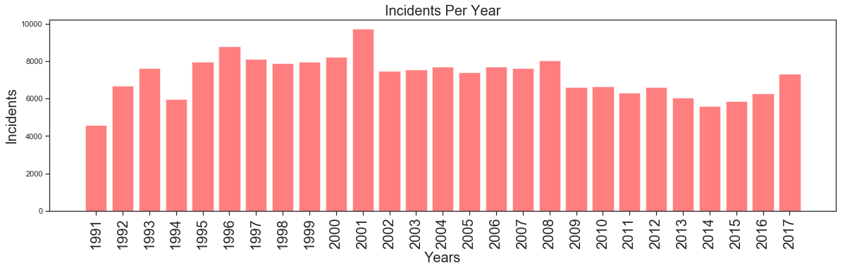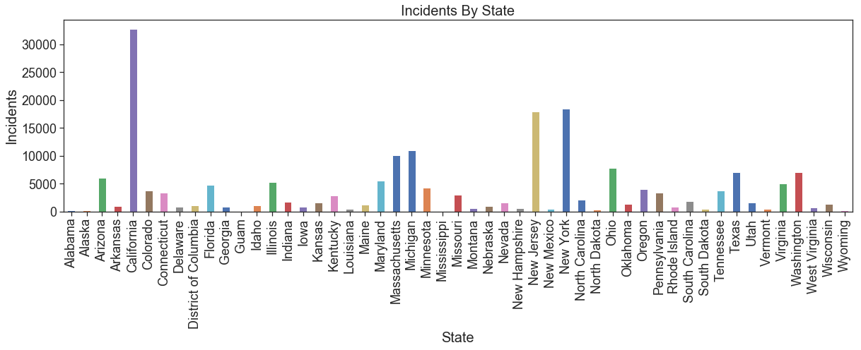

From a brief exploration of the data, we can see how the total number of hate crime incidences changes from year to year. When broken down by state, an initial glance suggests that a small subset of states contribute to a large portion of reported hate crimes.

**How are different hate crimes reported geographically, and does bias differ from state to state?**

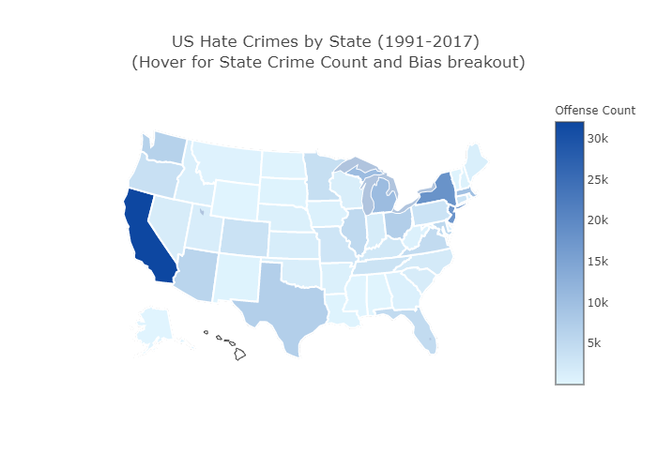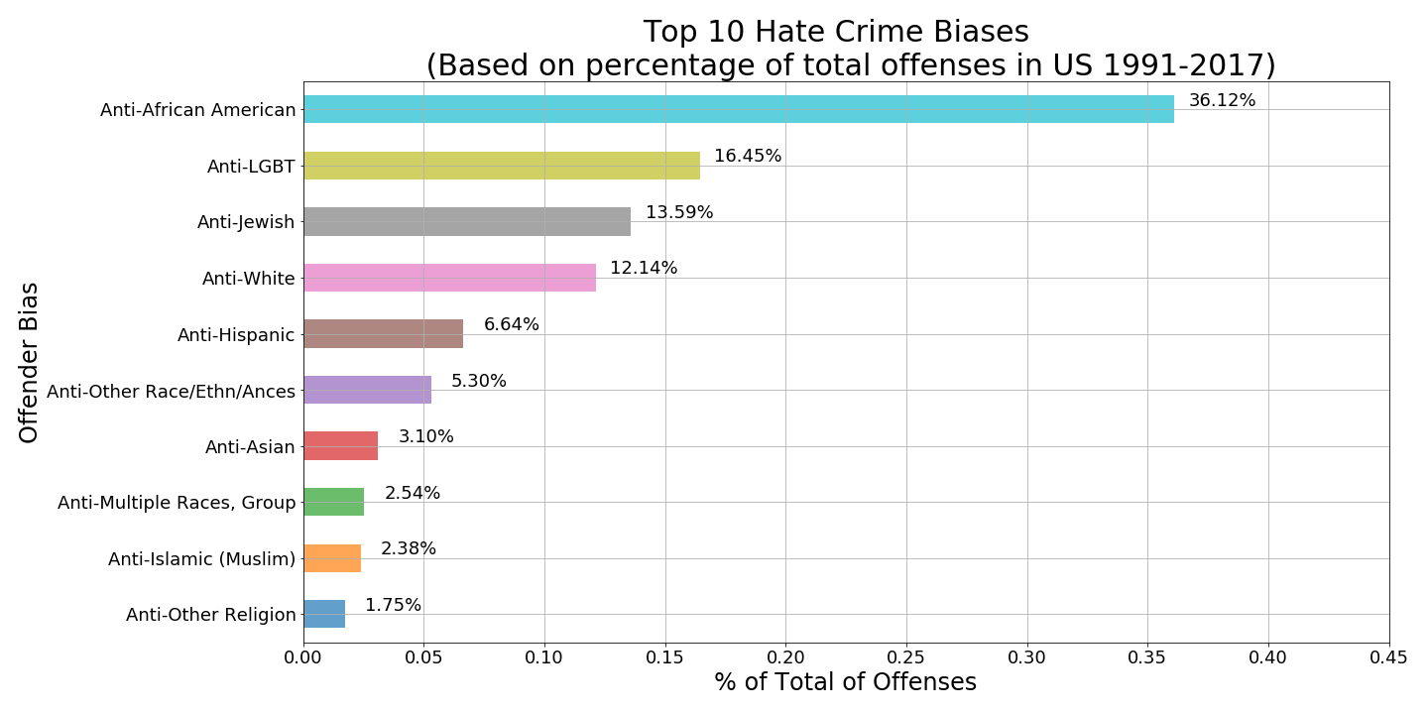

* A clear trend emerges in terms of the biases hate crime offenders display, with over 36% targeting African Americans, which is more than double the next most targeted group, LGBT at 16%.
* In the interactive map, hovering over each state displays the total number of hate crime incidences per state, as well as the top biases in hate crimes committed per state. This also shows a clear bias towards African Americans, with all states but two (New York and Arkansas), listing Anti-African American as the most common bias in recorded hate crimes.
* The color gradient of the map displays the number of hate crimes reported per state, but can be misleading because not all states record hate crimes as thoroughly as others, and some do not report at all.

**Does Hate Crime Change Over Time?**

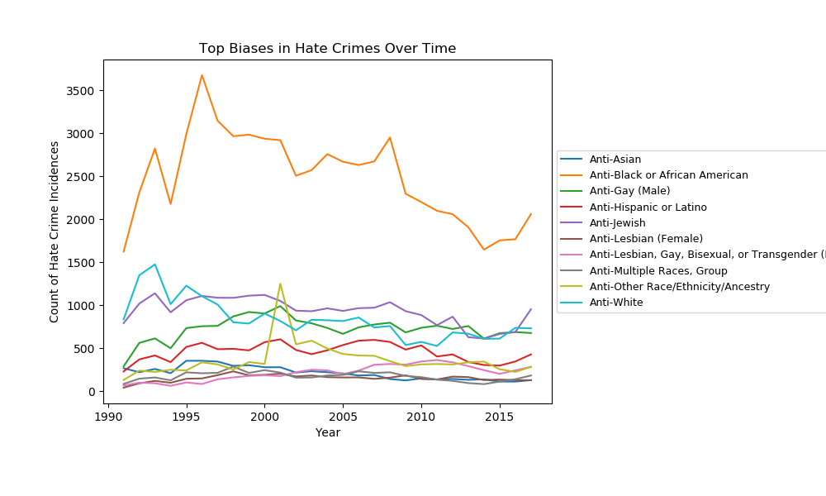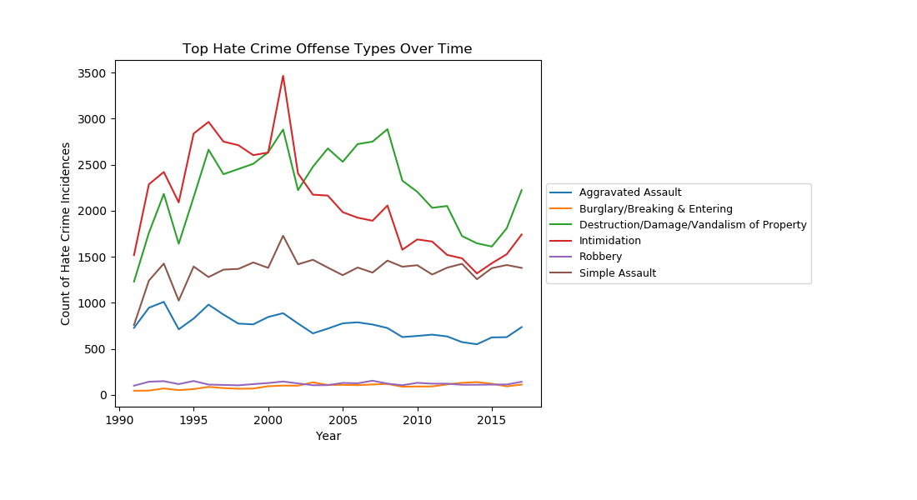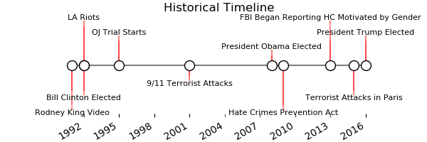

* Looking at different biases that motivated hate crimes, the most prevalent appear to have the greatest fluctuations in incidence counts from year to year.
* 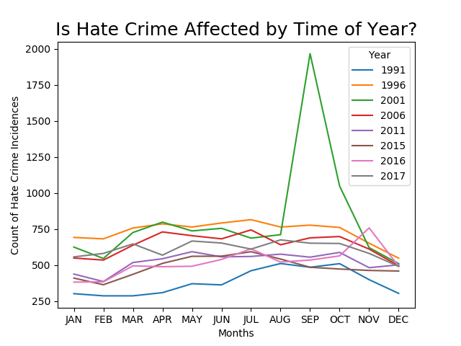Similarly, the top 4 offense types committed vary greatly from one year to the next, but the less common offenses experience little variation over time.
* Hate crime does appear to be affected by external sources like the current political climate, and significant world events.
* There appears to be some trend in hate crimes during particular months of the year (ex. Decrease in December), but most years appear to have their own variations.

**Do hate crime offense types vary by city size or by the bias underlying the crime?**

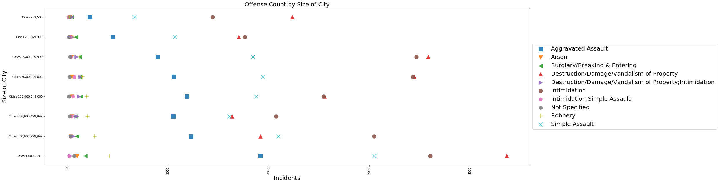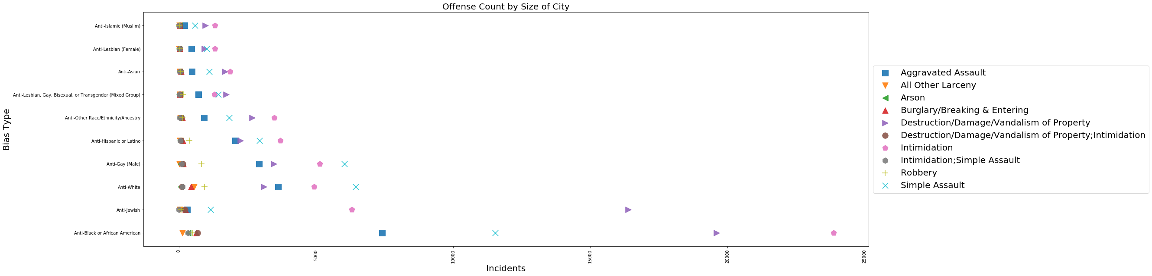

* The most common types of offenses due to hate crime appear to vary depending on the size of the city.
* Vandalism and destruction of property is common in most cities, but medium sized cities (2,500-250,00) are unique in that they also experience intimidation on a pretty equal basis.
* Assaults (both aggravated and simple) follow a regular trend of increasing as a city’s population increases.
* Intimidation is clearly one of the most common offense types for all hate crime biases, and is only significantly far from the top for Anti-Jewish hate crimes.

**Does household income affect the number of hate crimes reported?**

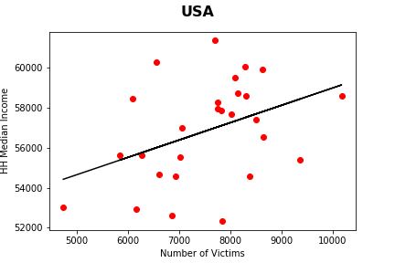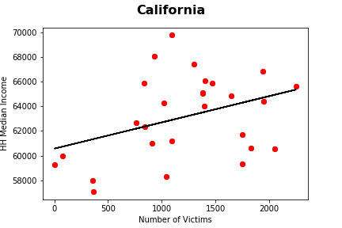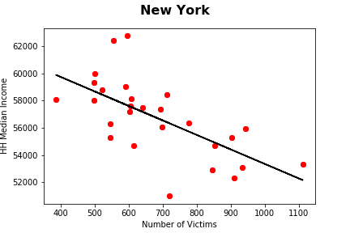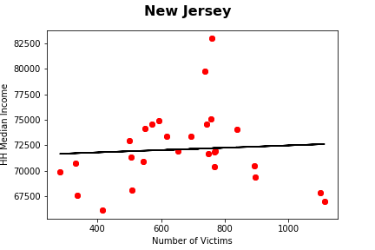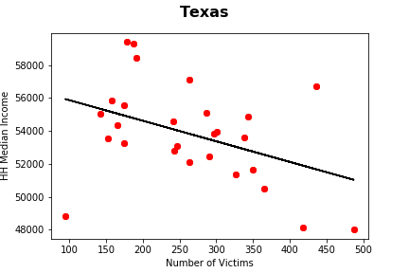

* The relationship between the median household income and number of hate crime incidences is viewed on both a national and state level (only four shown here).
* Overall there is a slightly positive correlation between rising household income and the rate of violent crime (based on national view). However, this correlation is not significant enough for us to confirm our hypothesis suggesting there is a relationship between the two.
* Income correlates only slightly with violent crime rates, but the results are mixed and very by state.